Course: MENG 2020 Computer Programming
Lab: Lab 03
Name: Michaël McCorkell | Student ID: N01500049
Date: October 10th 2026

Please refer to the lab manual posted on the blackboard and fill in the following table as your final lab report.

Please Notice: All the labs are individual work and submission. All academic misconduct behaviors will be penalized the maximum extent possible according to college policy. Thanks for your attention. (Reference Link: About Academic Misconduct)

Please finish all the lab report submission requirements in the following table. Add more rows if necessary.

Lab Results
Lab Procedures | Submission Requirements: Please submit screenshots showing your original Matlab code and the execution results for each step.  Note: If file submission is required, please attach your files separately on Blackboard.
1 | 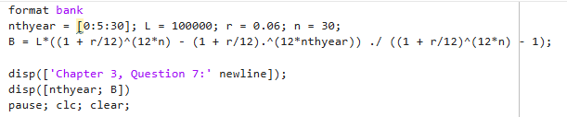  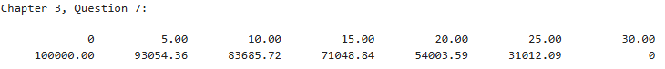  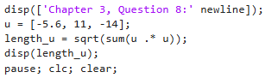  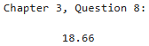  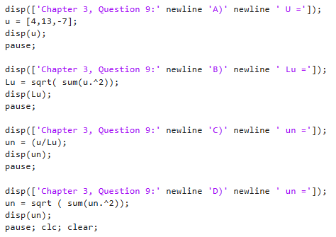  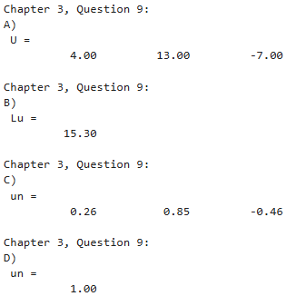  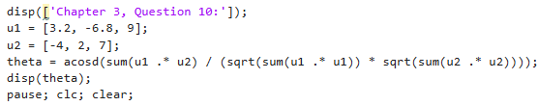  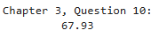
2 | 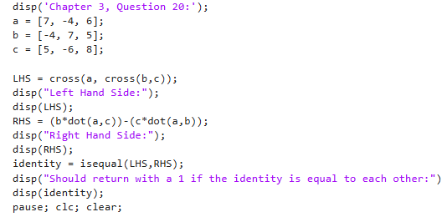  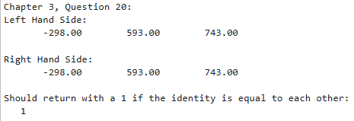  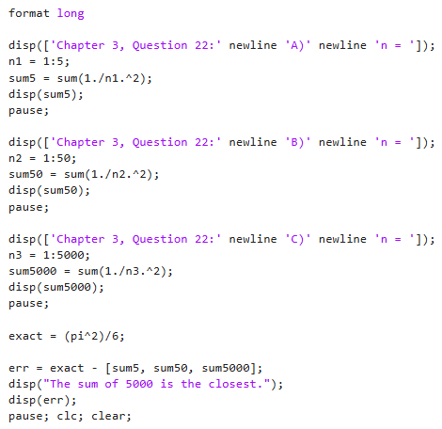  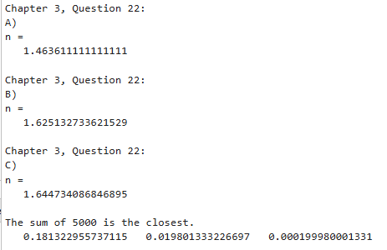  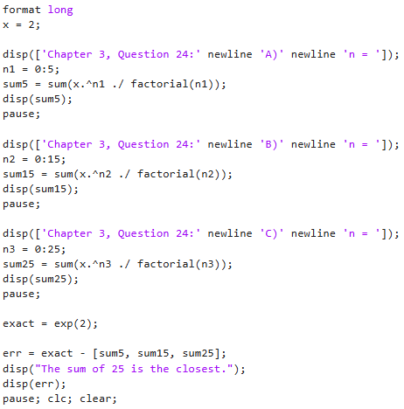  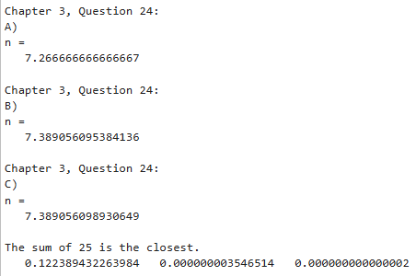  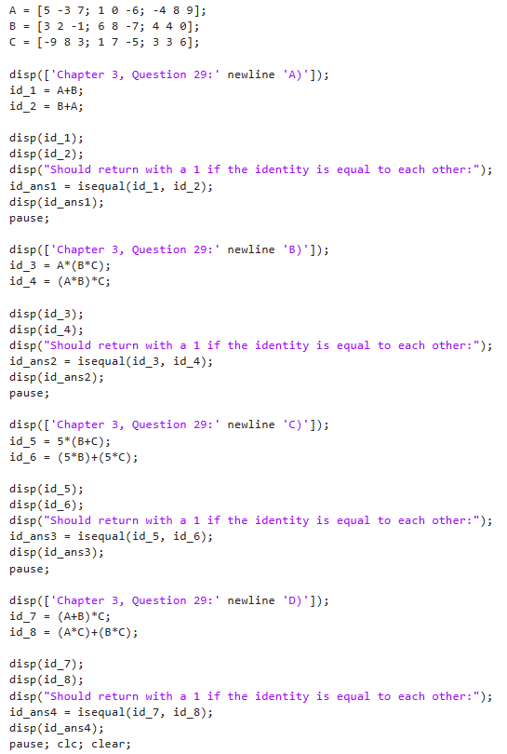  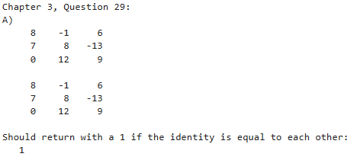  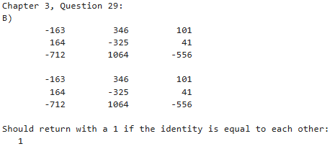  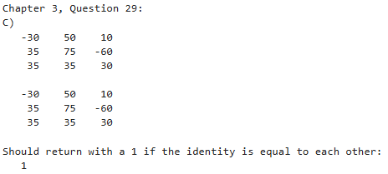  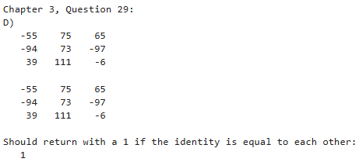  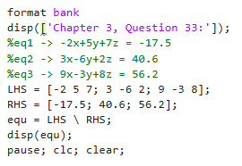  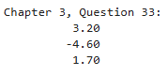  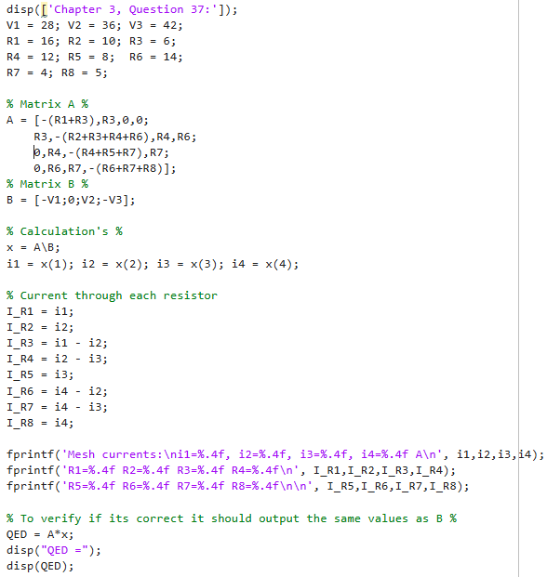  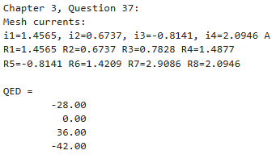

After Lab Practice Questions

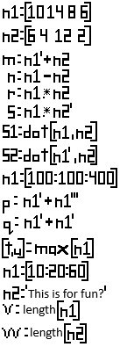
  Variable Name | Variable Value
  M | 16  18  20  8
  N
    4 | 8 | 2 | 0
    6 | 10 | 4 | 2
    -2 | 2 | -4 | -6
    8 | 12 | 6 | 4
  P | 200  400  600  800
  Q | 200  400  600  800
  R
    60 | 84 | 48 | 36
    40 | 56 | 32 | 24
    120 | 168 | 96 | 72
    20 | 28 | 16 | 12
  S
    60 | 56 | 96 | 12
  S1 | 224
  S2 | 224
  T | 400
  U | 4
  V | 16
  W | 3

